---Retrieve books currently borrowed by a specific member---

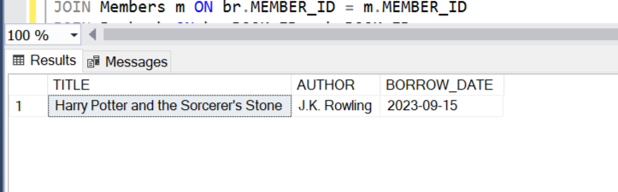

---Find members who have overdue books (borrowed more than 30 days ago, not returned)---

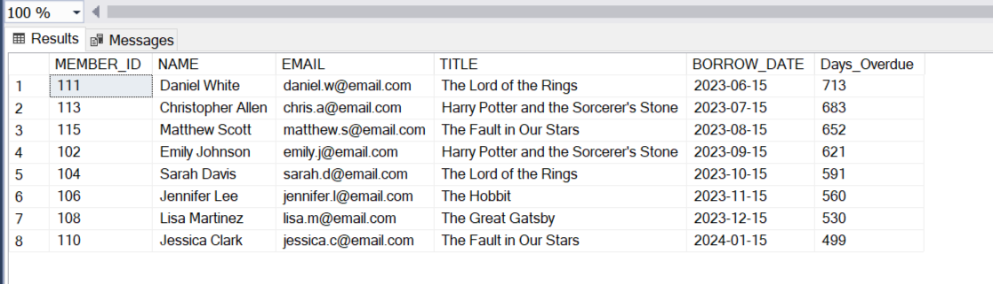

---Retrieve books by genre along with the count of available copies---

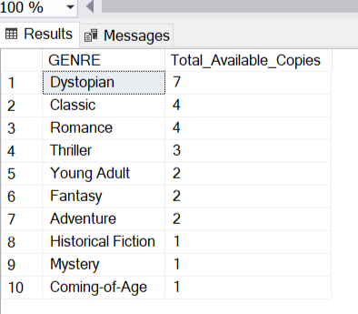

---Find the most borrowed books overall---

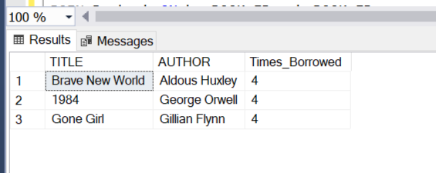

---Retrieve members who have borrowed books from at least three different genres---

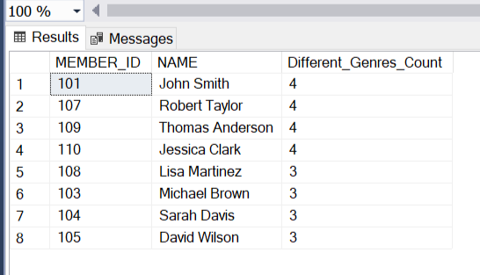

---Reporting and Analytics---

---Calculate the total number of books borrowed per month---

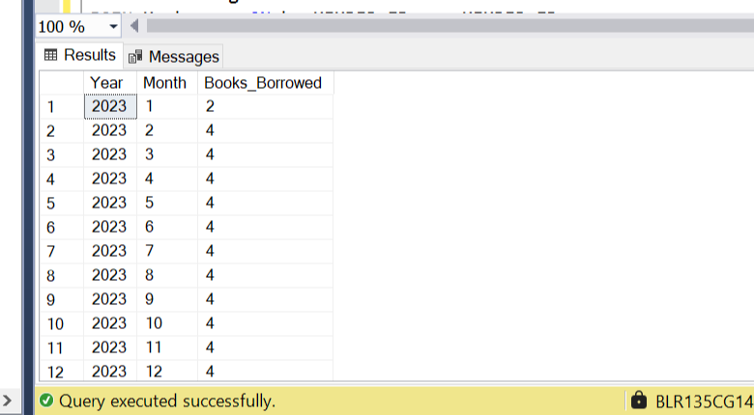

---Find the top three most active members based on the number of books borrowed---

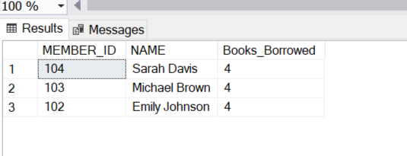

---Retrieve authors whose books have been borrowed at least 10 times---

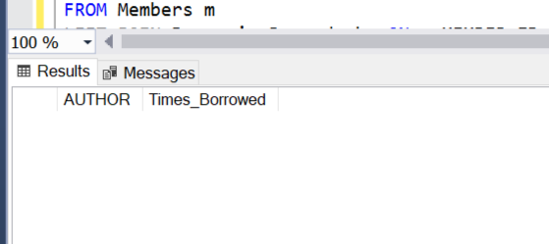

---Identify members who have never borrowed a book---

